

TREE CARE

HOME

FORESTRY
SERVICE

OUR
EQUIPMENT

JOBS

ONLINE SHOPPING

CONTACT

TREE SCIENCE
& PHILOSOPHY

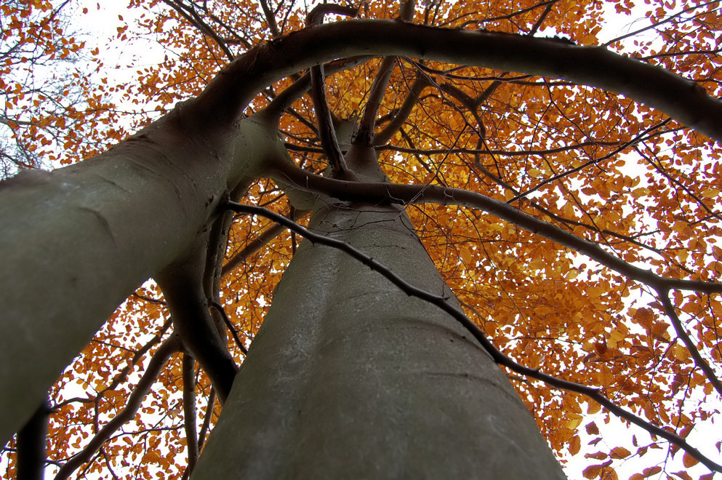
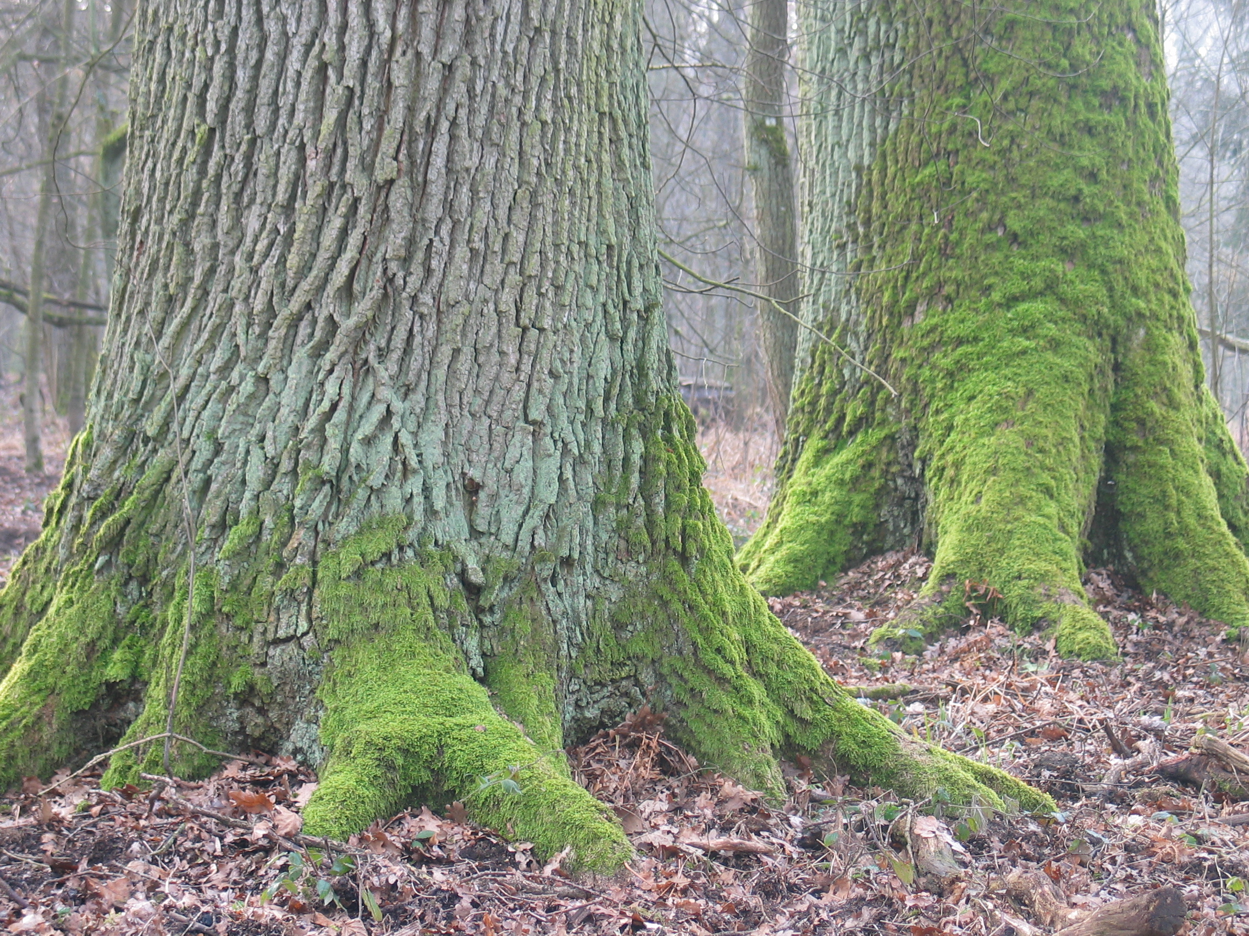

the materials of city planning are
SKY, SPACE, TREES, STEEL AND CEMENT
in that order and that hierarchy.
LeCorbusier (1887-1965) Swiss architect and city planner

Not sure about the health and structural stability of your trees?

Concerned about your trees overhanging any public roadways ? ( nat. road safety act, 1995 )

Contact us to get your trees checked by a certified arborist !

Tom Vaughan @ (087) 2544 129 office . . . . (057) 9331 990 mail . . . . info@vtc.ie

ONLINE SHOP
FORESTRY
PICTURE GALLERY
Tree Safety-Check from 50 €
fully insured & trained
nationwide service

VAUGHAN TREE CARE
Forestry & Timber

looking after all your needs in relation to modern tree management ,
e.g.:
- felling of dangerous roadside trees
- carrying out of crown thinning or crown lifting techniques for allowing
increased light filtration into your garden
- target pruning to acknowledged standards for improved crown balance and structural tree stability
- complete removal of overgrown evergreens
which, by the years, become increasingly costly for you to be kept in check
- planting of suitable hedging / shelter belts with easy-to-maintain species
- chipping and removal of debris from site
- stump grinding
- complete site clearance works

ask us for references

