

TREE CARE

HOME

FORESTRY
SERVICE

OUR
EQUIPMENT

JOBS

ONLINE SHOPPING

CONTACT

TREE SCIENCE
& PHILOSOPHY

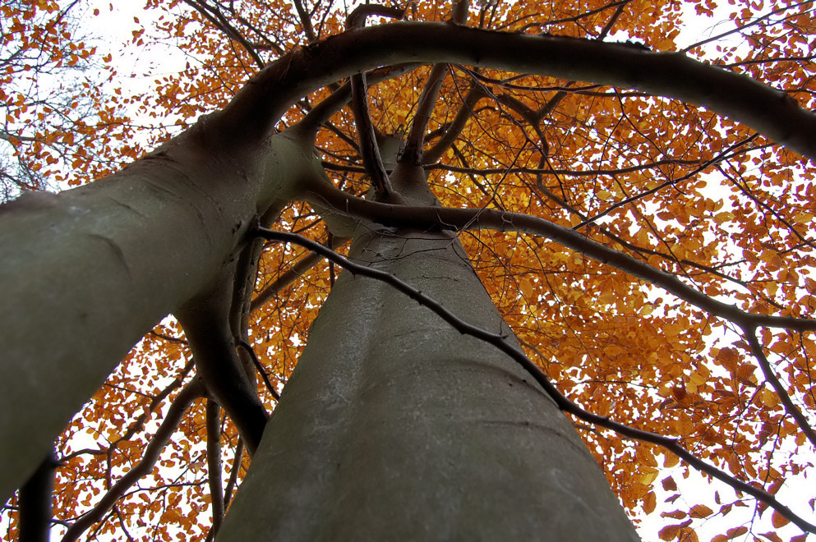

contact Tom
@ (087) 2544 129

office . . . . (057) 9331 990
mail . . . . . . . . info@vtc.ie

ONLINE SHOP
FORESTRY
TREE SURGERY
monthly special:
Tree Safety - Check from 50 €
fully insured & trained
nationwide service
Welcome

VAUGHAN TREE CARE
Forestry & Timber

specializing in professional hedge maintenance and qualified tree care
for a safe and healthy environment, e.g.:

- felling of dangerous roadside trees
- crown thinning, target pruning
- removal of overgrown evergreens
- wood chipping and stump grinding
- site clearance operations

. . . and also your partner for small to medium scale forestry maintenance
providing you with top-service on:

- forest thinning and tending works
- on-site wood chipping
- mobile firewood processing of your timber on-site

ask us for references
SHOP:
- Tree Marking Spray
- Storage Bags
for Firewood
- Firewood
- Trees & Shrubs
- This`n´That

