
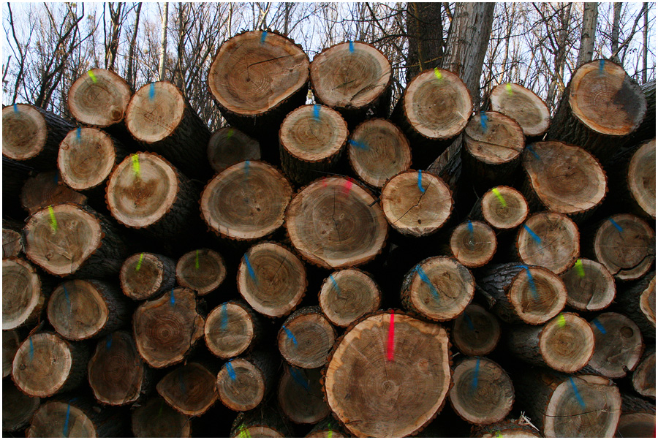
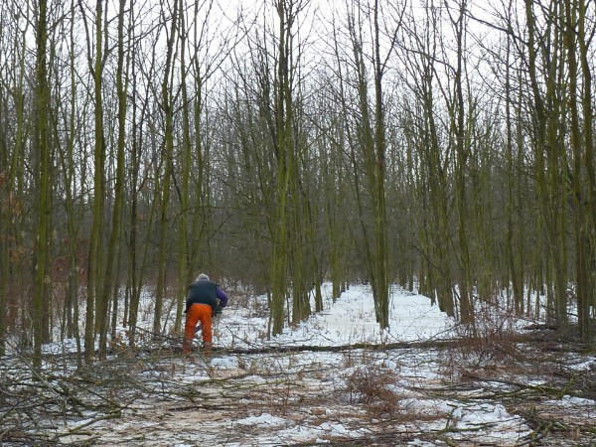

monthly special:
Vaughan Tree Care

Specialized in qualified tree and
hedge maintenance, e.g. the felling of dangerous roadside trees, crown thinning, target pruning, complete removal of overgrown evergreens including wood chipping and stump grinding.
. . . Vaughan Tree Care is looking after all your needs in relation to modern tree management works, e.g.
felling of dangerous roadside trees, crown thinning or crown lifting cuts to allow better light filtration into your garden,
target pruning to improve tree balance, complete removal of overgrown evergreens including wood chipping and stump grinding.

the materials of city planning are
SKY, SPACE, TREES, STEEL AND CEMENT
in hat order and that hierarchy.
LeCorbusier (1887-1965)
Swiss architect and city planner
contact Tom
@ (087)2544 129
VAUGHAN TREE CARE
Forestry & Timber

your partner for small to medium scale forestry (up to 40ha)

. . . careful timber extraction with the vitality of your asset in mind
in order to achieve best profits on the future growth of your timber stand :

- top-service on forest thinning and tending
- we buy & sell timber - standing, collected or delivered to one of our yards
- making a straight deal with you for your timber
- on-site wood chipping service
- on-site mobile firewood processing

ONLINE SHOP
Shop:
- Tree Marking Spray
- Storage Bags
for Firewood
- Firewood
- Trees & Shrubs
- This`n´That
TREE SURGERY
ask us for references
fully insured & trained
nationwide service

HOME

TREE CARE

FORESTRY
SERVICE

OUR
EQUIPMENT

TREE SCIENCE
& PHILOSOPHY

JOBS

CONTACT

ONLINE SHOPPING
Tom Vaughan @ (087)2544 129 office . . . . (057)9331 990 mail . . . . forestry&timber@vtc.ie

