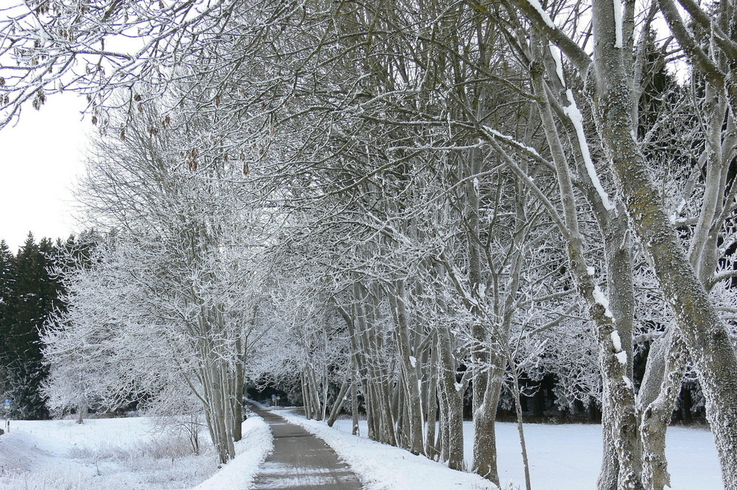
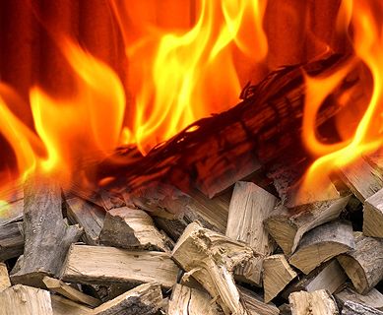
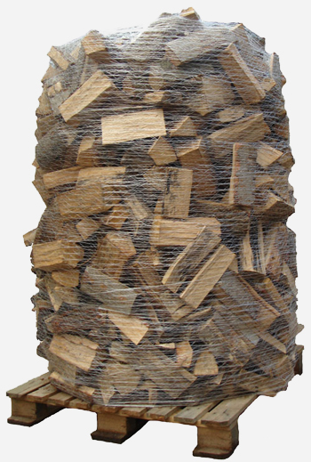
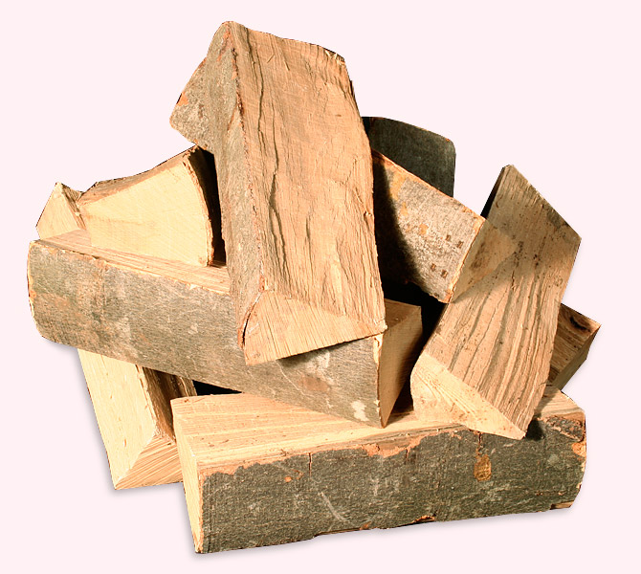
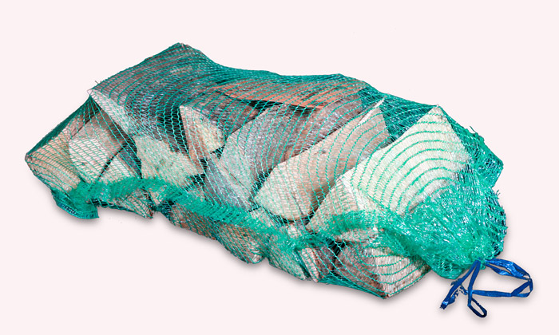

online firewoodstore
HOME
HARD/SOFT WOOD
MIX OF TIMBER
HOME &
GIFTS
PRICE
LIST
FORESTRY
SUPPLIES
TREES &
SHRUBS
MAP
ORDERS
. . we deliver ready to use FIRELOGS in various size bags to your requirements:

click & pick
Loose Firewood loads
Big Bags
Trolley Bags
Handy Sacs
Best quality Firewood

Delivered to your doorstep,
grown and harvested within the region and naturally seasoned for cracking hot fires !
Timber logs we store:

- Spruce/Softwood for quick
heat and an easy to start fire !

- Ash, Beech, Oak /Hardwood for great calorific value and a longer lasting flame !
…and more
you might warm up with !

firewoodstore
online
supporting Irish firewood sales and local jobs !

